1.Git Setup<https://confluence.atlassian.com/bitbucket/set-up-git-744723531.html>

Cmd- sudo apt-get install git

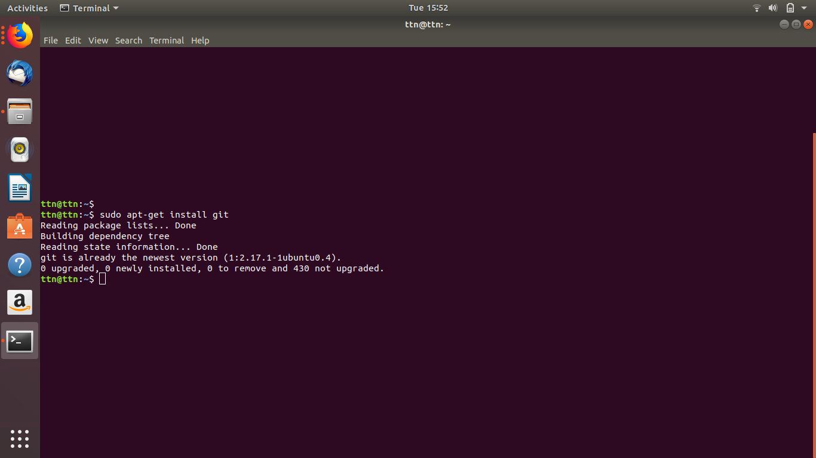

2.Initialize a Git Repository

Cmd- git init

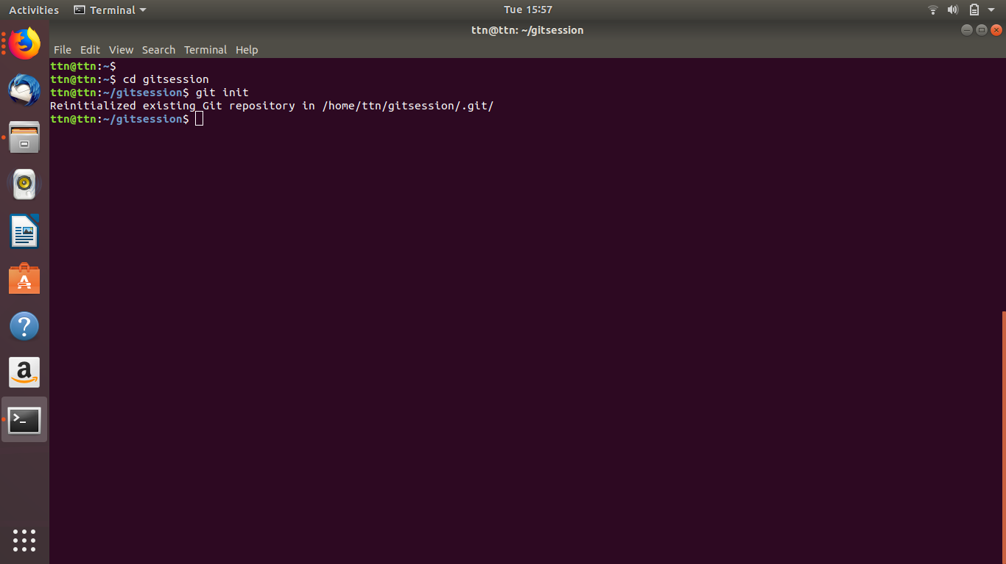

3.Add files to the repository

Cmd -vim my.txt

Git add .

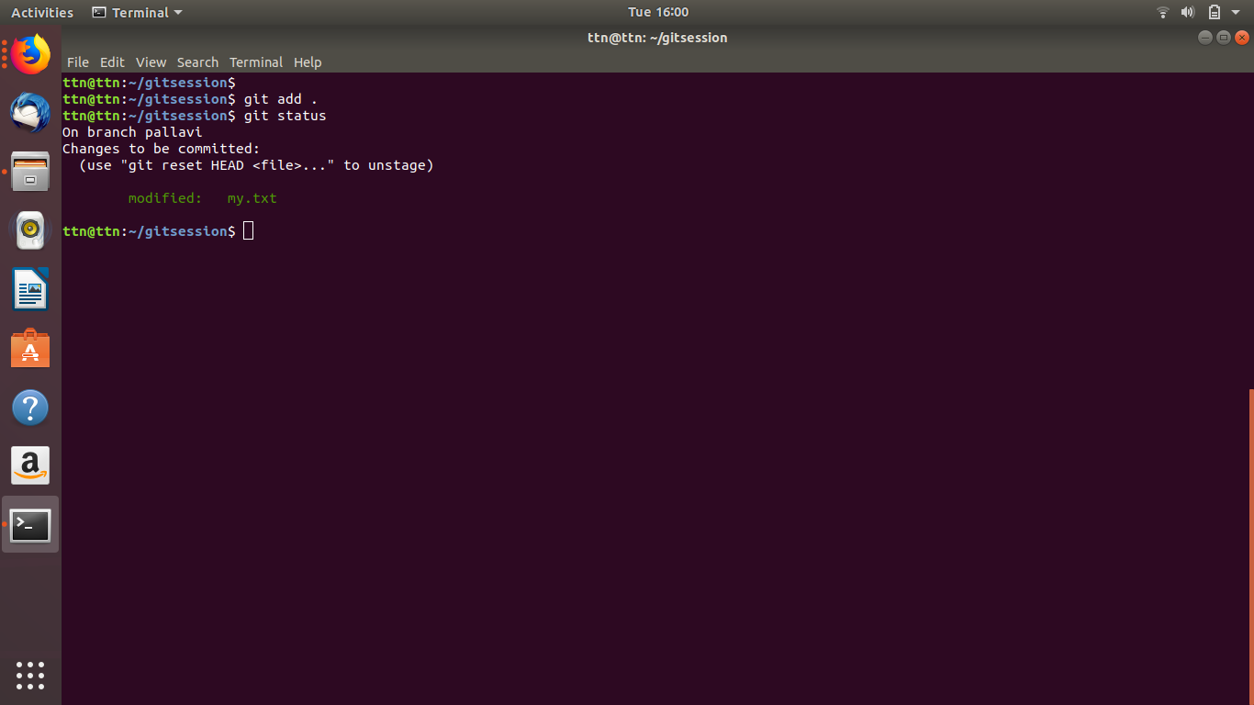

4.Unstage 1 file

Cmd - git reset HEAD my.txt

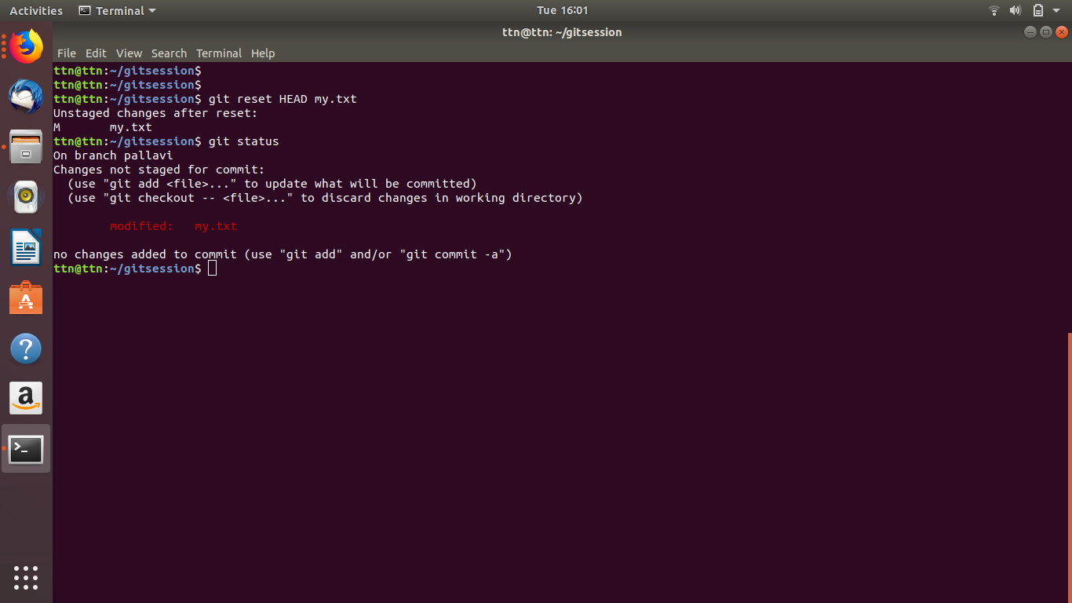

5.Commit the file

Cmd- git commit -m “first time commit”

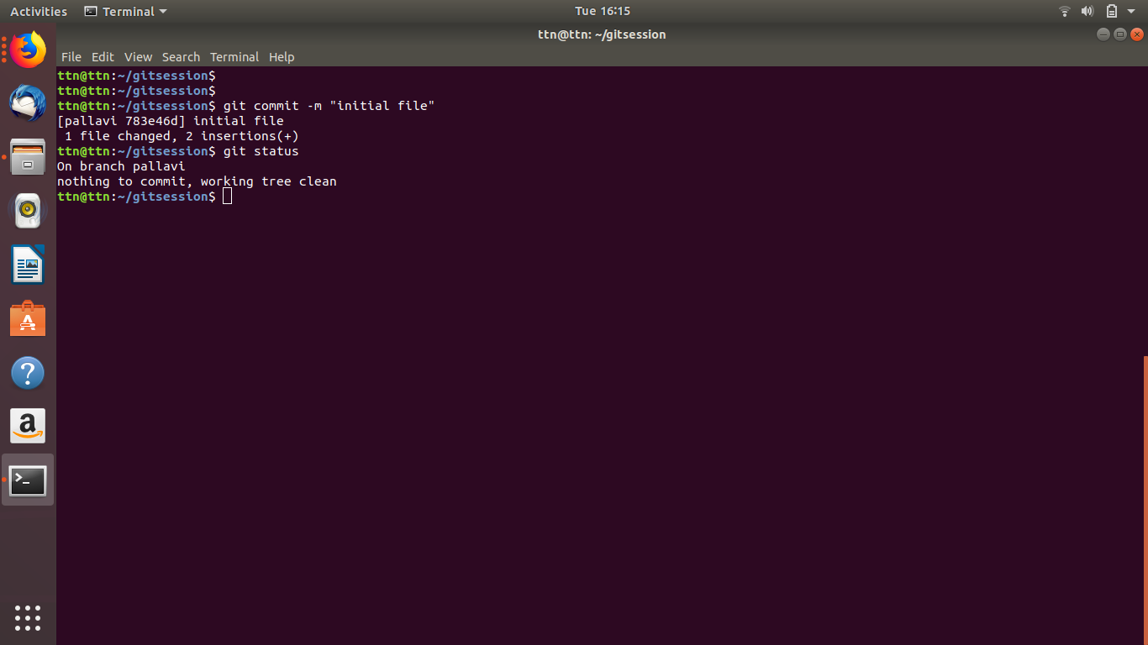

6. Add a remote

Cmd- git remote add pt <url>

Git remote -v

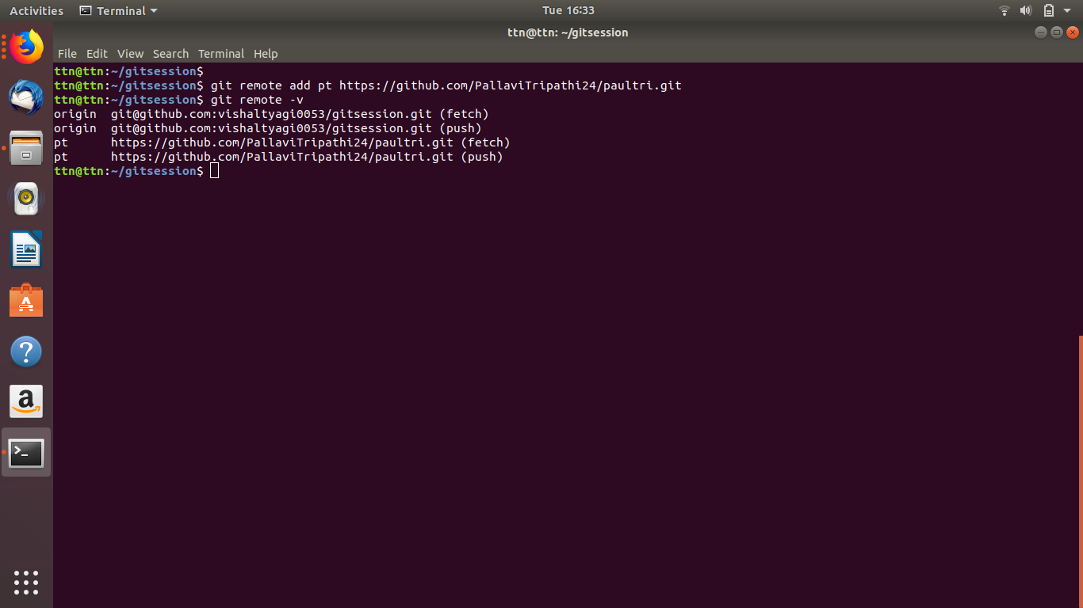

7.Undo changes to a particular file

Cmd -

8.Push changes to Github

Cmd - git add .

git commit

Git push --set-upstream origin pallavi

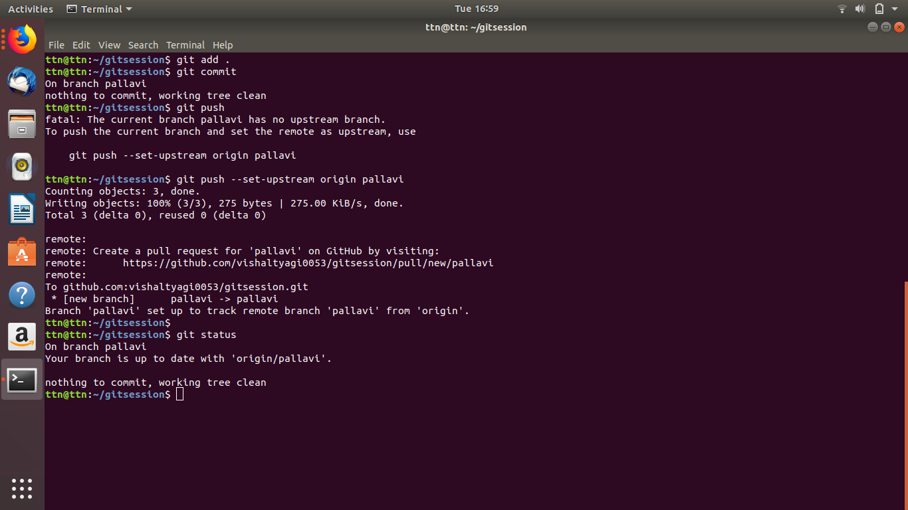

9. Clone the repository

Cmd - git clone https://github.com/PallaviTripathi24/paultri.git

10.Add changes to one of the copies and pull the changes in the other.

Cmd- git checkout pallavi1

Git add .

Git pull origin pallavi

Git push -u origin pallavi1

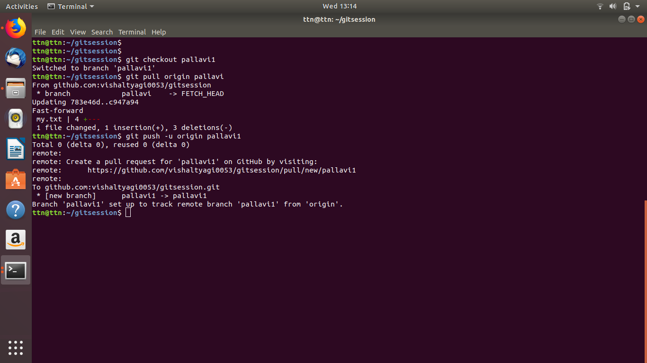

11.Check differences between a file and its staged version

Cmd - git diff --staged

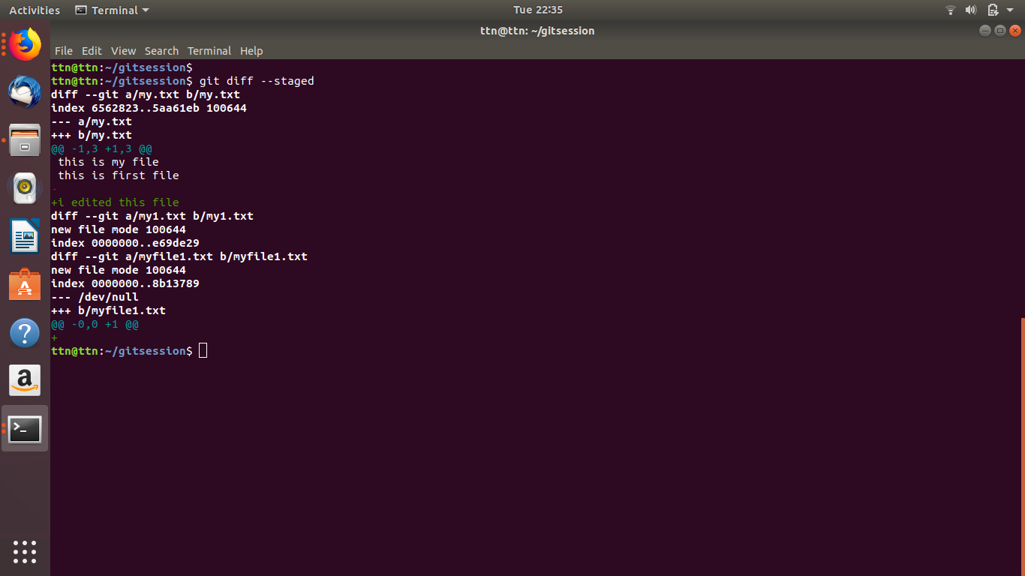

12.Ignore a few files to be checked in

Cmd -touch .gitignore

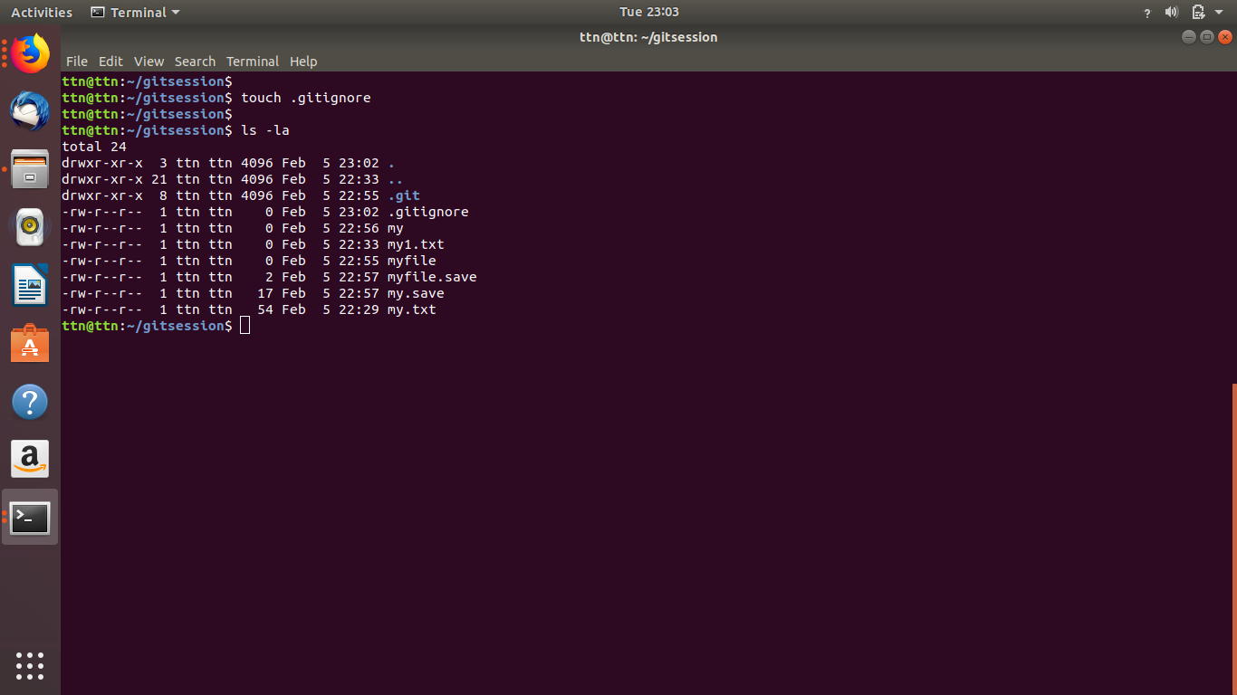

13.Create a new branch.

Cmd - git branch pallavi1

git branch pallavi

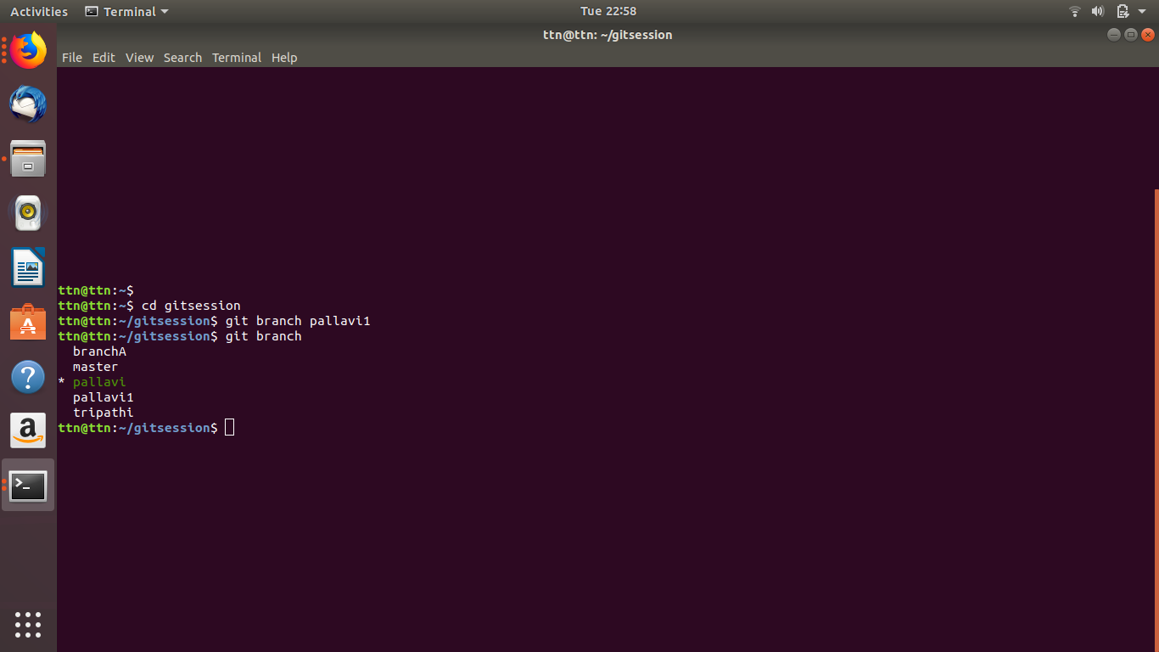

14.Diverge them with commits

Cmd - git log --graph

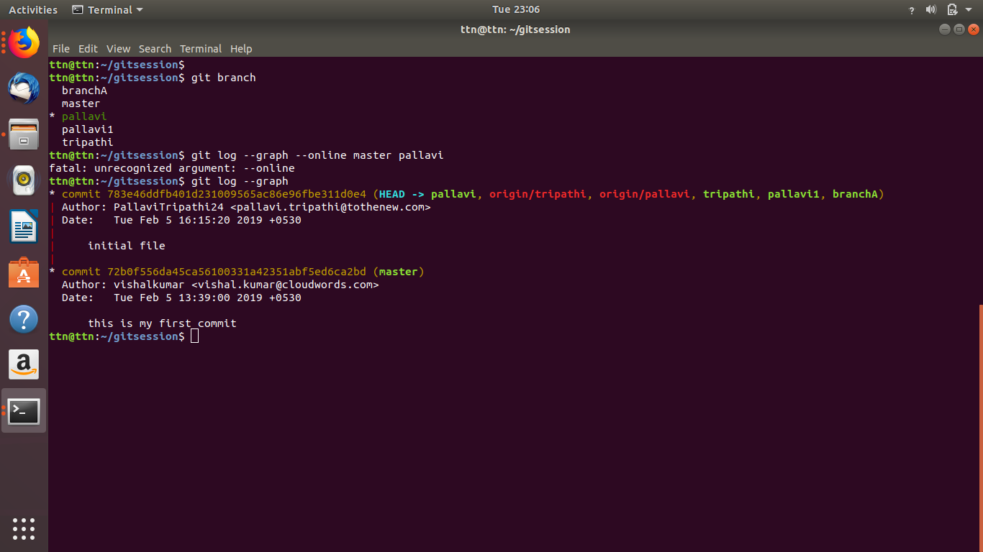

15.Edit the same file at the same line on both branches and commit

Cmd- git checkout pallavi

Vim my.txt

(there is change in third line)

Git commit -m “changed”

Git checkout master

Git pull origin master

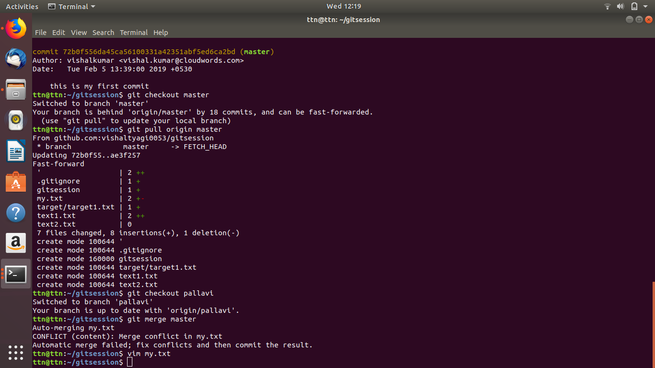

16. Try merging and resolve merge conflicts

Cmd - git merge master

To resolve conflict--deleted the conflicting lines

Git add .

Git commit -m “resolve merge conflict”

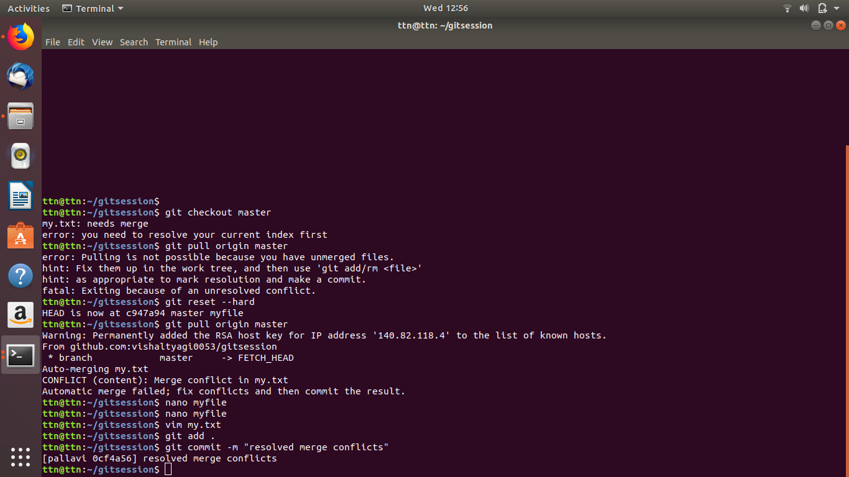

17.Stash the changes and pop them

Cmd- git stash

Git diff

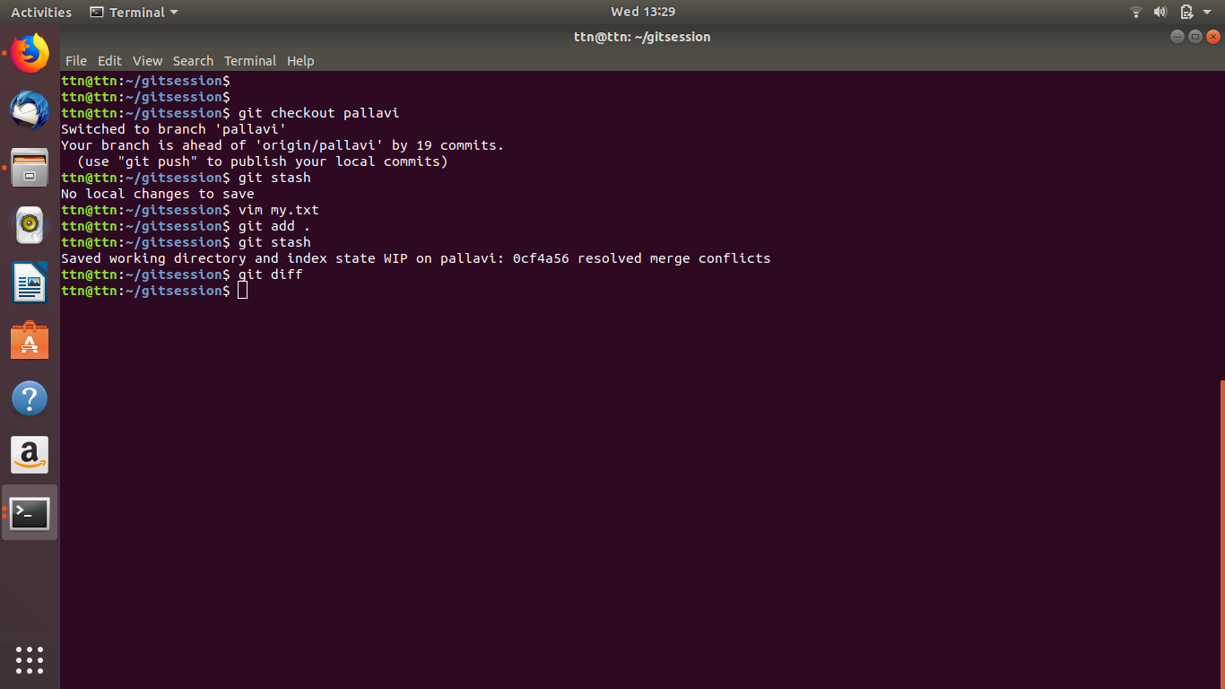

18.Add the following code to your .bashrc file : color_prompt="yes"

parse_git_branch() {

git branch 2> /dev/null | sed -e '/^[^*]/d' -e 's/* \(.*\)/(\1)/'

}

if [ "$color_prompt" = yes ]; then

PS1='\u@\h\[\033[00m\]:\[\033[01;34m\]\W\[\033[01;31m\] $(parse_git_branch)\[\033[00m\]\$ '

else

PS1='\u@\h:\W $(parse_git_branch)\$ '

fi

unset color_prompt force_color_prompt

Cmd -vim ~/.bashrc

